Tourism Management System

Abstract:
This is a Tourism website database management system where users can browse through all the available tour packages and book the package. Tourists can see all places that they can visit in their journey. Users can cancel their booking till one day before the journey. Users can give feedback after their tour journey.

E-R Diagram:

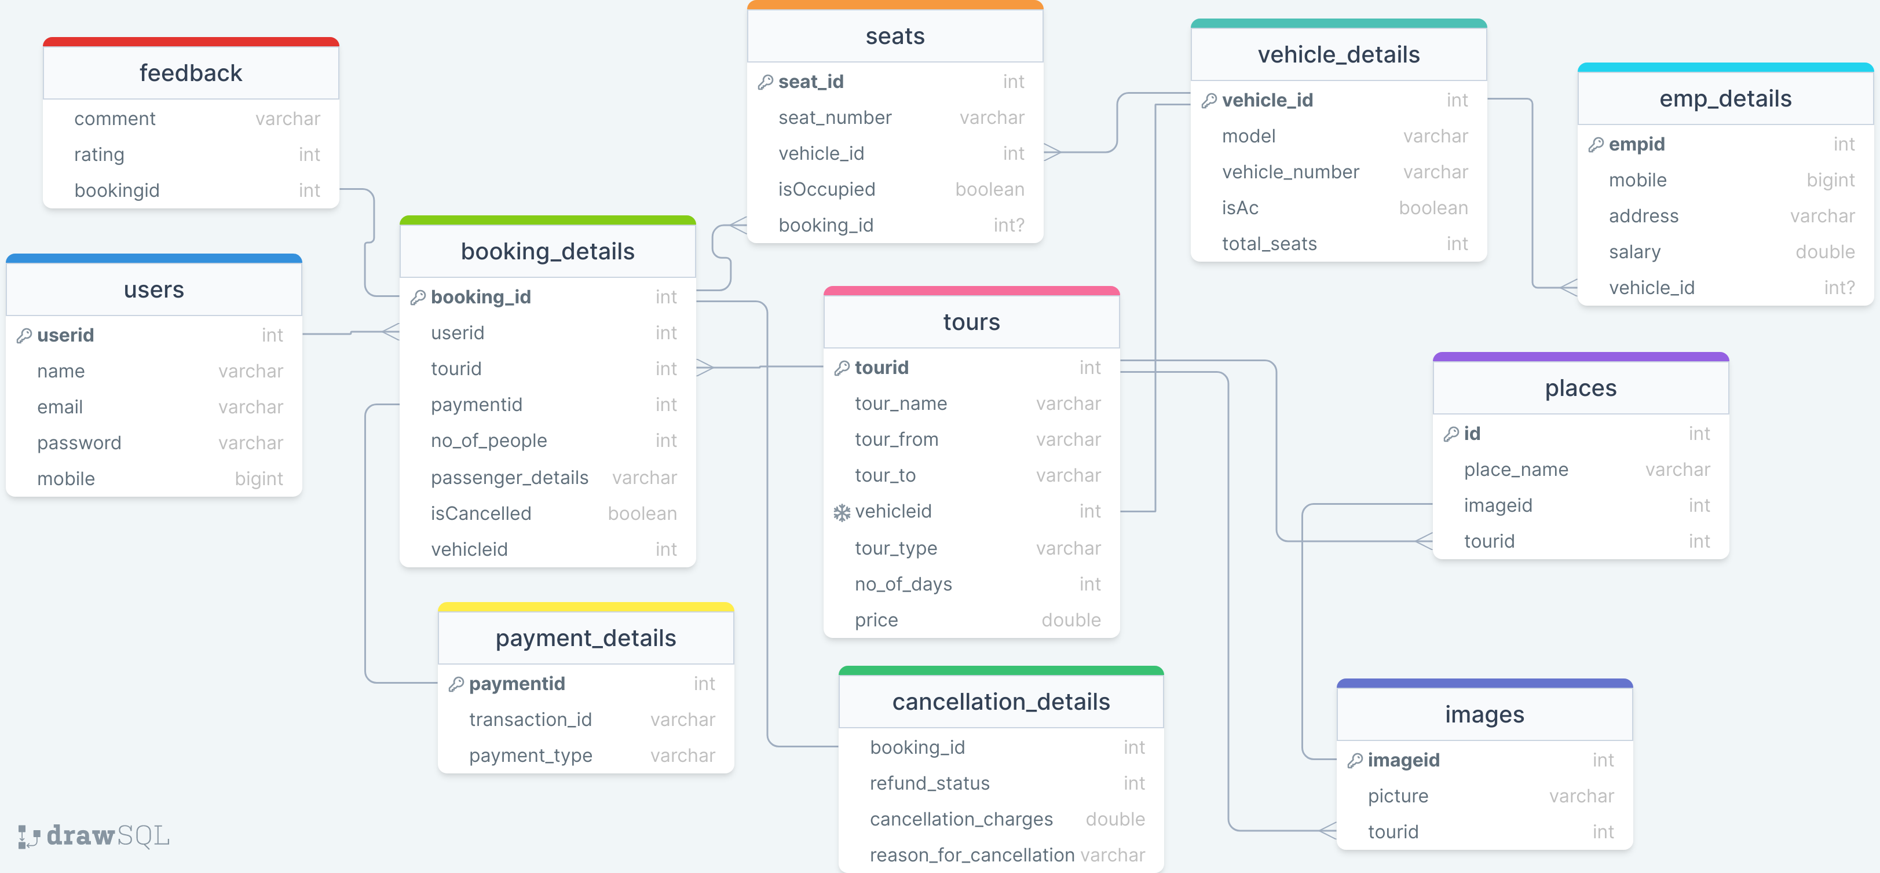

SQL TABLES:

CREATE TABLE `tours`(
`tourid` INT UNSIGNED NOT NULL AUTO_INCREMENT,
`tour_name` VARCHAR(255) NOT NULL,
`tour_from` VARCHAR(255) NOT NULL,
`tour_to` VARCHAR(255) NOT NULL,
`vehicleid` INT NOT NULL,
`tour_type` VARCHAR(255) NOT NULL,
`no_of_days` INT NOT NULL,
`price` DOUBLE NOT NULL
);
ALTER TABLE
`tours` ADD PRIMARY KEY `tours_tourid_primary`(`tourid`);
ALTER TABLE
`tours` ADD UNIQUE `tours_vehicleid_unique`(`vehicleid`);
CREATE TABLE `places`(
`id` INT UNSIGNED NOT NULL AUTO_INCREMENT,
`place_name` VARCHAR(255) NOT NULL,
`imageid` INT NOT NULL,
`tourid` INT NOT NULL
);
ALTER TABLE
`places` ADD PRIMARY KEY `places_id_primary`(`id`);
CREATE TABLE `images`(
`imageid` INT UNSIGNED NOT NULL AUTO_INCREMENT,
`picture` VARCHAR(255) NOT NULL,
`tourid` INT NOT NULL
);
ALTER TABLE
`images` ADD PRIMARY KEY `images_imageid_primary`(`imageid`);
CREATE TABLE `users`(
`userid` INT UNSIGNED NOT NULL AUTO_INCREMENT,
`name` VARCHAR(255) NOT NULL,
`email` VARCHAR(255) NOT NULL,
`password` VARCHAR(255) NOT NULL,
`mobile` BIGINT NOT NULL
);
ALTER TABLE
`users` ADD PRIMARY KEY `users_userid_primary`(`userid`);
CREATE TABLE `vehicle_details`(
`vehicle_id` INT UNSIGNED NOT NULL AUTO_INCREMENT,
`model` VARCHAR(255) NOT NULL,
`vehicle_number` VARCHAR(255) NOT NULL,
`isAc` TINYINT(1) NOT NULL,
`total_seats` INT NOT NULL
);
ALTER TABLE
`vehicle_details` ADD PRIMARY KEY `vehicle_details_vehicle_id_primary`(`vehicle_id`);
CREATE TABLE `emp_details`(
`empid` INT UNSIGNED NOT NULL AUTO_INCREMENT,
`mobile` BIGINT NOT NULL,
`address` VARCHAR(255) NOT NULL,
`salary` DOUBLE NOT NULL,
`vehicle_id` INT NULL
);
ALTER TABLE
`emp_details` ADD PRIMARY KEY `emp_details_empid_primary`(`empid`);
CREATE TABLE `booking_details`(
`booking_id` INT UNSIGNED NOT NULL AUTO_INCREMENT,
`userid` INT NOT NULL,
`tourid` INT NOT NULL,
`paymentid` INT NOT NULL,
`no_of_people` INT NOT NULL,
`passenger_details` VARCHAR(255) NOT NULL,
`isCancelled` TINYINT(1) NOT NULL,
`vehicleid` INT NOT NULL
);
ALTER TABLE
`booking_details` ADD PRIMARY KEY `booking_details_booking_id_primary`(`booking_id`);
CREATE TABLE `cancellation_details`(
`booking_id` INT UNSIGNED NOT NULL AUTO_INCREMENT,
`refund_status` INT NOT NULL,
`cancellation_charges` DOUBLE NOT NULL,
`reason_for_cancellation` VARCHAR(255) NOT NULL
);
CREATE TABLE `payment_details`(
`paymentid` INT UNSIGNED NOT NULL AUTO_INCREMENT,
`transaction_id` VARCHAR(255) NOT NULL,
`payment_type` VARCHAR(255) NOT NULL
);
ALTER TABLE
`payment_details` ADD PRIMARY KEY `payment_details_paymentid_primary`(`paymentid`);
CREATE TABLE `seats`(
`seat_id` INT UNSIGNED NOT NULL AUTO_INCREMENT,
`seat_number` VARCHAR(255) NOT NULL,
`vehicle_id` INT NOT NULL,
`isOccupied` TINYINT(1) NOT NULL,
`booking_id` INT NULL
);
ALTER TABLE
`seats` ADD PRIMARY KEY `seats_seat_id_primary`(`seat_id`);
CREATE TABLE `feedback`(
`comment` VARCHAR(255) NOT NULL,
`rating` INT NOT NULL,
`bookingid` INT NOT NULL
);
ALTER TABLE
`booking_details` ADD CONSTRAINT `booking_details_tourid_foreign` FOREIGN KEY(`tourid`) REFERENCES `tours`(`tourid`);
ALTER TABLE
`tours` ADD CONSTRAINT `tours_vehicleid_foreign` FOREIGN KEY(`vehicleid`) REFERENCES `vehicle_details`(`vehicle_id`);
ALTER TABLE
`places` ADD CONSTRAINT `places_imageid_foreign` FOREIGN KEY(`imageid`) REFERENCES `images`(`imageid`);
ALTER TABLE
`places` ADD CONSTRAINT `places_tourid_foreign` FOREIGN KEY(`tourid`) REFERENCES `tours`(`tourid`);
ALTER TABLE
`booking_details` ADD CONSTRAINT `booking_details_userid_foreign` FOREIGN KEY(`userid`) REFERENCES `users`(`userid`);
ALTER TABLE
`feedback` ADD CONSTRAINT `feedback_bookingid_foreign` FOREIGN KEY(`bookingid`) REFERENCES `booking_details`(`booking_id`);
ALTER TABLE
`seats` ADD CONSTRAINT `seats_vehicle_id_foreign` FOREIGN KEY(`vehicle_id`) REFERENCES `vehicle_details`(`vehicle_id`);
ALTER TABLE
`seats` ADD CONSTRAINT `seats_booking_id_foreign` FOREIGN KEY(`booking_id`) REFERENCES `booking_details`(`booking_id`);
ALTER TABLE
`images` ADD CONSTRAINT `images_tourid_foreign` FOREIGN KEY(`tourid`) REFERENCES `tours`(`tourid`);
ALTER TABLE
`emp_details` ADD CONSTRAINT `emp_details_vehicle_id_foreign` FOREIGN KEY(`vehicle_id`) REFERENCES `vehicle_details`(`vehicle_id`);
ALTER TABLE
`cancellation_details` ADD CONSTRAINT `cancellation_details_booking_id_foreign` FOREIGN KEY(`booking_id`) REFERENCES `booking_details`(`booking_id`);
ALTER TABLE
`booking_details` ADD CONSTRAINT `booking_details_paymentid_foreign` FOREIGN KEY(`paymentid`) REFERENCES `payment_details`(`paymentid`);

